

Grenloch
Preschool
Lunch Menu
September 2023

MONDAY | TUESDAY | WEDNESDAY | THURSDAY | FRIDAY
 |  |  |  | 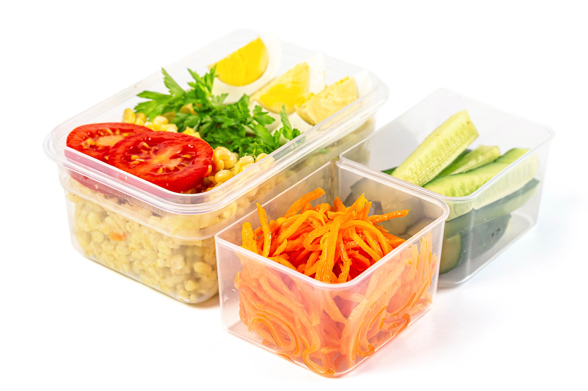 | More Info…  Welcome to Grenloch Preschool!!  If there is anything that you need from the Food Service Department, give us  a call at  856-582-4010  Price:  Students: $3.50  Milk Choice  1% Low-fat White    Water Is Available for Purchase  Turkey Pepperoni, Cheese & Cracker Anytimers, Soy Butter & Jelly Sandwiches and Yogurt Lunchables are Available Daily as Alternates to the Main Menu
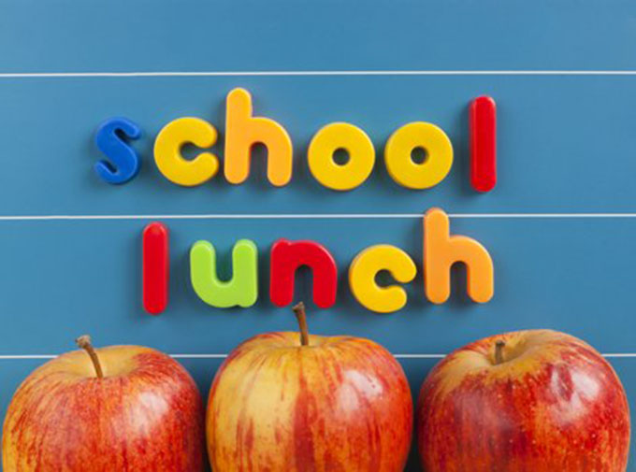 |  | 6  Jimmy Dean Pancake on a Stick  Chilled Applesauce  Veggie Juice  Milk | 7  Turkey & Ham Croissant  Chilled Peaches  Bagged Carrots w/ Dip  Milk | 8  Pizza Boli OR Galaxy Pizza  Craisins  Celery Sticks w/ Dip  Milk
11  Cheesy Croissant Sandwich  Gogurt/Yogurt  Chilled Pears  Bagged Carrots w/ Dip  Milk | 12  Taco Snack  w/ Sour Cream  Chilled Peaches  Veggie Juice  Milk | 13  Grilled Cheese  Chilled Applesauce  Sliced Cucumbers w/ Dip  Milk | 14  Turkey Pretzel Dog  Banana  Veggie Juice  Milk | 15  Galaxy Pizza  Craisins  Celery Sticks w/ Dip  Milk
18  Egg & Cheese on an English Muffin  Chilled OJ  Bagged Carrots w/ Dip  Milk | 19  Mini Blueberry Waffles  Cheese Stick & Gogurt  Chilled Peaches  Veggie Juice  Milk | 20  Jimmy Dean Pancake on a Stick  Chilled Applesauce  Veggie Juice  Milk | 21  Beef Sausage & Cheese on a Bagel  Chilled Peaches  Bagged Carrots w/ Dip  Milk | 22  Pizza Boli OR Galaxy Pizza  Craisins  Celery Sticks w/ Dip  Milk
25  Cheesy Croissant Sandwich  Gogurt/Yogurt  Chilled Pears  Bagged Carrots w/ Dip  Milk | 26  Taco Snack  w/ Sour Cream  Chilled Peaches  Veggie Juice  Milk | 27  Grilled Cheese  Chilled Applesauce  Sliced Cucumbers w/ Dip  Milk | 28  Turkey Pretzel Dog  Banana  Veggie Juice  Milk | 29  Galaxy Pizza  Craisins  Celery Sticks w/ Dip  Milk

Washington Township Pre-School Lunch Menu
Meal Applications Now Available Online!  www.Payschoolscentral.com  WT Food Service Department 856-582-4010 | Menus are subject to change without notice.  *IW=Individually Wrapped

